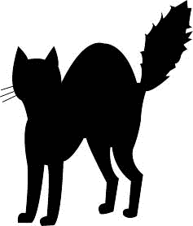
Halloween colors

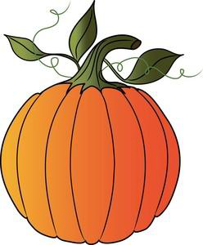
Black cat.
Orange pumpkin.
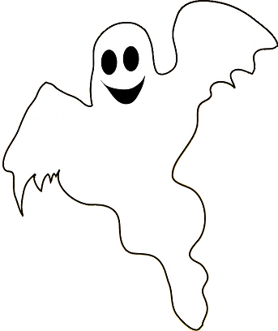
White ghost.
Green-eyed monster.
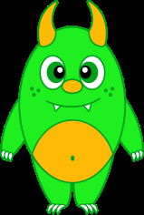
Black, orange, white, green.
These are the colors of Halloween !
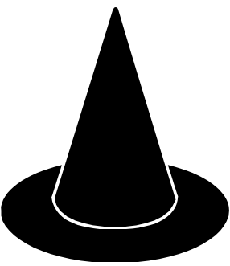
Black cats.
Witches’ hats.
Jack-o’-lanterns.
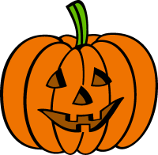
Jack-o’-lanterns.
Black, orange, white, green.
These are the colors of Halloween !

Halloween colors

Black cat.
Orange pumpkin.
White ghost.
Green-eyed monster.
Black, orange, white, green.
These are the colors of Halloween !
Black cats.
Witches’ hats.
Jack-o’-lanterns.
Jack-o’-lanterns.
Black, orange, white, green.
These are the colors of Halloween !

Halloween colors

Black cat.
Orange pumpkin.
White ghost.
Green-eyed monster.
Black, orange, white, green.
These are the colors of Halloween !
Black cats.
Witches’ hats.
Jack-o’-lanterns.
Jack-o’-lanterns.
Black, orange, white, green.
These are the colors of Halloween !

