THE BEATLES : « Hello, goodbye »

You say yes, I say no,
You say stop, I say go, go, go.

Oh no ...
You say goodbye and I say hello, hello, hello.
I don't know why you say goodbye I say hello, hello, hello.
I don't why you say goodbye I say hello.

I say high, you say low.
You say why and I say I don't know.

Oh no ...
You say goodbye and I say hello, hello, hello.
I don't know why you say goodbye I say hello, hello, hello.
I don't know why you say goodbye I say hello.
Why, why, why, why, why, why, do you
Say goodbye, goodbye, bye, bye.

Oh no ...
You say goodbye and I say hello, hello, hello.
I don't know why you say goodbye I say hello, hello, hello.
I don't know why you say goodbye I say hello.
You say yes, I say no (I say yes but I may mean no)
You say stop and I say go, go, go (I can stay till it's time to go)

Oh, oh no …
You say goodbye and I say hello, hello, hello.
I don't know why you say goodbye I say hello, hello, hello.
I don't know why you say goodbye I say hello, hello, hello.
I don't know why you say goodbye I say hello, hello, hello.
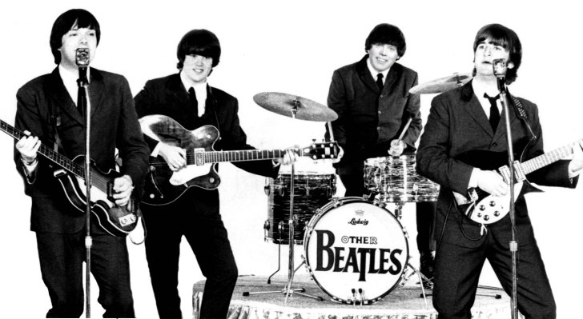
Hello, hello, hello.
Hello, hello, hello.
Hela, heba, helloa.

THE BEATLES : « Hello, goodbye »

You say yes, I say no,
You say stop, I say go, go, go.

Oh no ...
You say goodbye and I say hello, hello, hello.
I don't know why you say goodbye I say hello, hello, hello.
I don't why you say goodbye I say hello.

I say high, you say low.
You say why and I say I don't know.

Oh no ...
You say goodbye and I say hello, hello, hello.
I don't know why you say goodbye I say hello, hello, hello.
I don't know why you say goodbye I say hello.
Why, why, why, why, why, why, do you
Say goodbye, goodbye, bye, bye.

Oh no ...
You say goodbye and I say hello, hello, hello.
I don't know why you say goodbye I say hello, hello, hello.
I don't know why you say goodbye I say hello.
You say yes, I say no (I say yes but I may mean no)
You say stop and I say go, go, go (I can stay till it's time to go)

Oh, oh no …
You say goodbye and I say hello, hello, hello.
I don't know why you say goodbye I say hello, hello, hello.
I don't know why you say goodbye I say hello, hello, hello.
I don't know why you say goodbye I say hello, hello, hello.
Hello, hello, hello.
Hello, hello, hello.
Hela, heba, helloa.

